Henry “Box” Brown

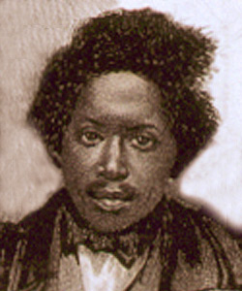

The baggage handlers ignored the "This Side Up with Care" label and rudely pushed the wooden box onto the ship’s deck with those words exactly on the bottom. They would have been surprised to learn that inside the crate was a man—Henry Brown, a slave who was mailing himself to freedom.

Born in Virginia in 1815, Henry was smart and was quickly noticed by his master. When Henry was 15, his master died, and he was sent to work in a tobacco factory. He married a woman named Nancy. Later, Henry watched as Nancy and their three children were sold away to North Carolina. Henry decided he would not stay a slave any longer. He decided to mail himself to a free state.

James C.A. Smith, a free black, and Samuel Smith, a white storekeeper, agreed to help Henry. Henry paid $86 to be mailed to Philadelphia. James Miller McKim would accept the box in Philadelphia.

On March 29, 1849, Brown squeezed into a wooden crate 3 feet long, 2 feet wide and 2.6 feet deep. With three holes across from his face for air and some water, he began his "battle of liberty," as he called it.

He bumped and thumped for 27 hours as the box traveled in wagons, on railroad cars, on the deck of a steam boat. Finally, a delivery wagon delivered him to McKim's home in Philadelphia.

McKim and a group of friends were waiting for their special delivery, and they gathered around the box. Henry kept quiet. Finally, he heard someone ask, "Is all right within?" He replied, "All right.'' The box was broken open. Brown tried to stand and passed out, but he had won his battle for freedom.

1. What is this story mostly about?

Henry’s family and friends

Henry’s journey to freedom

Slaves and their masters

1. What city did Henry mail himself to?

Philadelphia

McKim

North Carolina

1. Why did Henry’s wife and children leave?

They didn’t like him anymore.

They were mad.

They were sold.

1. Why did Henry’s box need three holes?

So that Henry could breathe

So that the box would be pretty

So people could poke him

Open Response

Name three people who helped Henry on his journey to freedom.

______________________________________________________________________________________________________________________________________________________________________________________________________________________________________________________________________________________________________________________________________________________________________________________________________________________________________________________________________________________________________________________________________________________________________________________________________________________________________________________________